TABLE OF CONTENTS

Page Number

1. **Introduction** 1

1.1 **About** 1

1.2 **Users** 1

1.3 **System Requirements** 1

2. **Getting Started** 2

2.1 **Logging In** 2

2.2 **Home Page** 3

2.3 **Create New User** 3

3. **Browse Cards** 4

3.1 **Site Navigation** 4

3.2 **Search Query** 4

4. **Create Card** 5

4.1 **Title** num

4.2 **Title** num

4.3 **Title** num

5. **Generate File** 7

5.1 **Title** num

5.2 **Title** num

5.3 **Title** num

6. **Modify Card** 9

6.1 **Title** num

6.2 **Title** num

6.3 **Title** num

7. **Edit Image** 12

7.1 **Title** num

7.2 **Title** num

7.3 **Title** num

8. **Troubleshooting** 15

8.1 **Title** num

8.2 **Title** num

8.3 **Title** num

Introduction

**About**

Midwestern State University Card Services is a program designed to combined Midwestern State University student identifications with their respective Wells Fargo® banking account. In coordination with Wells Fargo®, students are able use their card as their Midwestern State University identification card and as a Wells Fargo® banking/debit card.

This website is designed to provide Midwestern State University Card Services administrators with an easy-to-use graphical interface. All functionalities of this website meet all requirements of the users and administrators. These requirements include: create a student identification card, generate a new student profile, modify existing student profile, edit image of student profile, and browse all existing student profiles.

**Users**

The users of this website are the employees and administrators at the Midwestern State University Information Desk and the faculty member in charge of the development of this website. The users will interact with the system to complete all functional requirements. The users are the primary actors in all use cases for this website. The primary actors are those who interact with the system on a daily basis and with the customer. The daily users include the student assistant at the information and the full-time employees of the Midwestern State University Information Desk.

**System Requirements**

Administrators and users of this website are encouraged to access this website through the following web browsers: Google Chrome version 56.0.2924.76 or later, Mozilla Firefox 51.0 or later.

Getting Started

**Logging In**

To begin using the Card Services app, you will need to obtain a username and password from the system administrator. Once this is done, navigate to the Card Services URL at [url] in a supported browser. You will then see a login page as shown in Figure 1.

**Figure 1. Login Page**

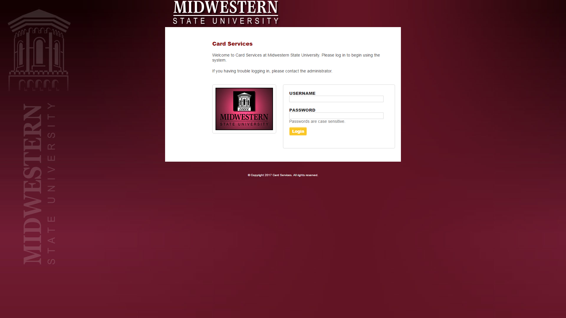

To log in from the login page, simply input your username and password into the appropriate fields and click the login button. If the username and password you input were valid, you will then be redirected to the home page as shown in Figure 2.

**Figure 2. Homepage**

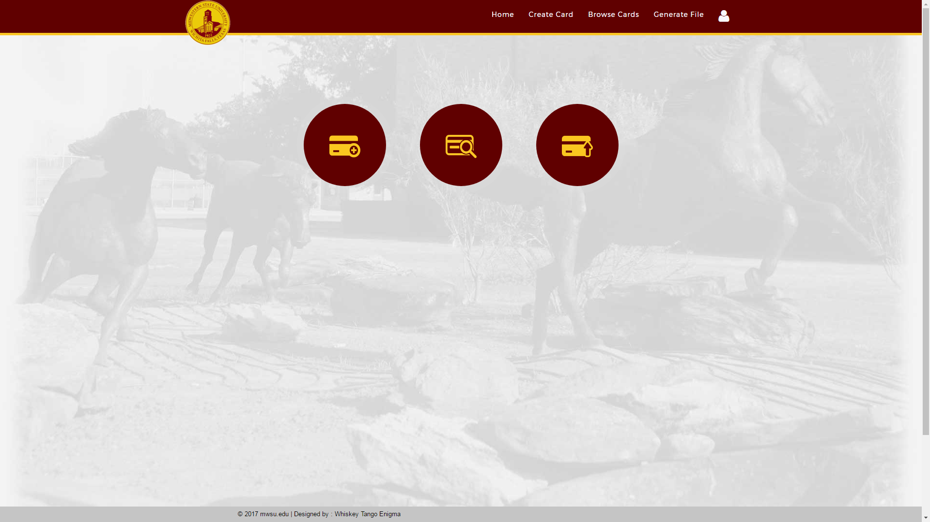

**Homepage**

From the homepage, you can then navigate to the pages for creating, modifying, and browsing cards, as well as modifying card images and generating card files. To navigate to a page, simply click on its name in the top bar, or the appropriate icon in the main portion of the page.

**Create New User**Lorem ipsum dolor sit amet.

Browse Cards

Create Card

Generate File

Modify Card

Edit Image

Troubleshooting